DISTRIBUTION STATEMENT A. Approved for public release. Distribution is unlimited.
This material is based upon work supported by the United States Air Force under Air Force Contract No. FA8702-15-D-0001. Any opinions, findings, conclusions or recommendations expressed in this material are those of the author(s) and do not necessarily reflect the views of the United States Air Force.

MITLL COVID Visitor Pass
Attestation App Guide

Overview

Starting on September 22, 2020, only authorized visitors who have a valid COVID Visitor Pass will be able to enter MIT Lincoln Laboratory facilities. Each COVID Visitor Pass is good until midnight and requires an initial acknowledgement of compliance with the requirements for accessing the Laboratory, and a daily health attestation. A new COVID Visitor Pass must be obtained each day a guest visits before entry will be allowed.
All Laboratory visitors must complete a daily Visitor COVID-19 Consent and Attestation form. If any of your responses present a conflict with the Laboratory’s current COVID-19 guidelines, you will be denied access to the Laboratory facilities/grounds (see page 10).
This guide is provided to instruct visitors to Lincoln Laboratory how to access and use this application:
- Accessing the application
- Logging into the application
- Completing the acknowledgement form
- Completing the self-attestation form
- Paper form (if needed)

Accessing the COVID Visitor Pass app …

Use a web browser …
To access the MIT COVID Visitor Pass application from your personal devices including mobile devices (iPhone, Android), laptops and desktops (including Mac, Windows, and Linux machines), open a web browser on your device and go to https://attestation.ll.mit.edu/

Creating an account
The first time you access the COVID Visitor Pass application, you will need to create a user account.
All fields are mandatory.
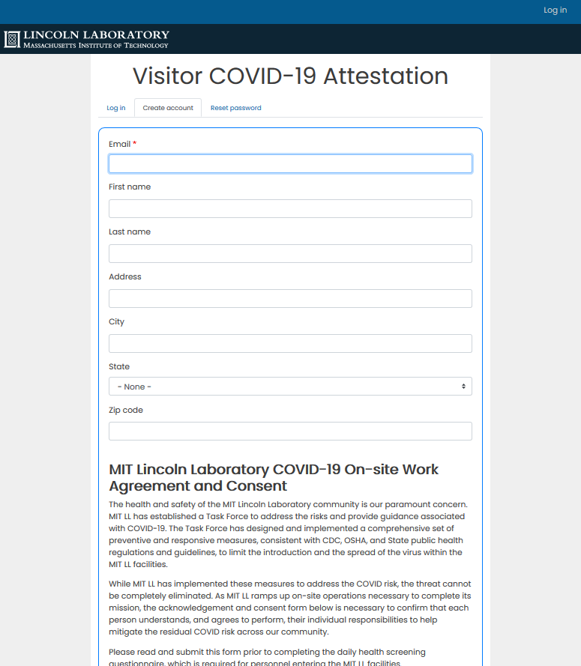
As part of creating your account, the application will display the COVID-19 Agreement and Consent form. You’ll need to agree to this acknowledgement to continue.

- Read the acknowledgement.
- Select “…this form” at the bottom of the form.
Click “Create new account”
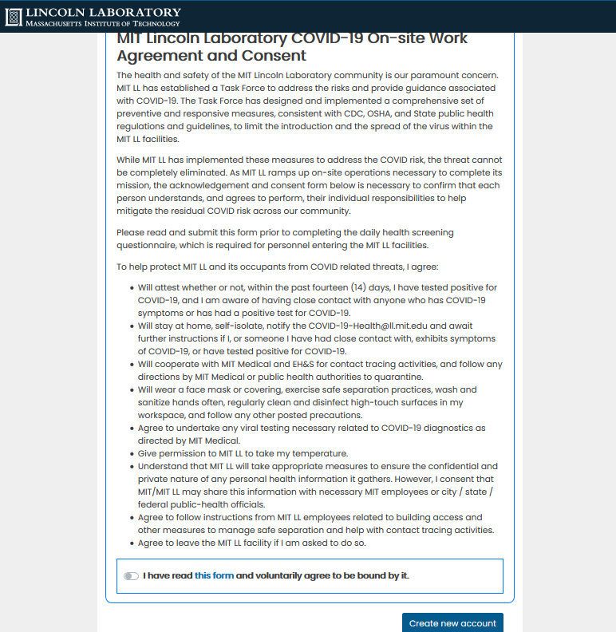
Once you’ve agreed to this acknowledgement, the app will bypass this step in all successive visits and will go directly to the attestation form. If the Agreement and Consent change, you will be asked to agree to the changes the next time you log in.

You will receive an email with a link to log into the application and set your password. You will receive a message that an email has been sent to the address you provided:
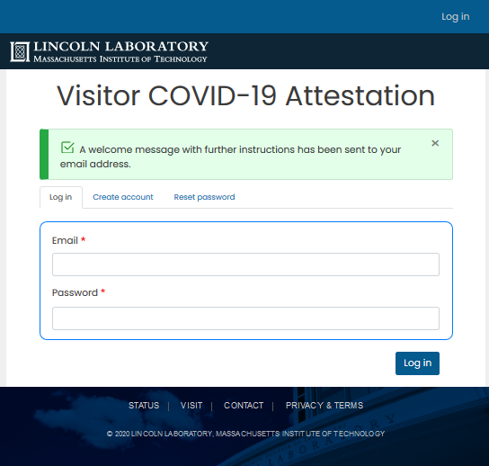

Click on the links in the email to log in and set your password:
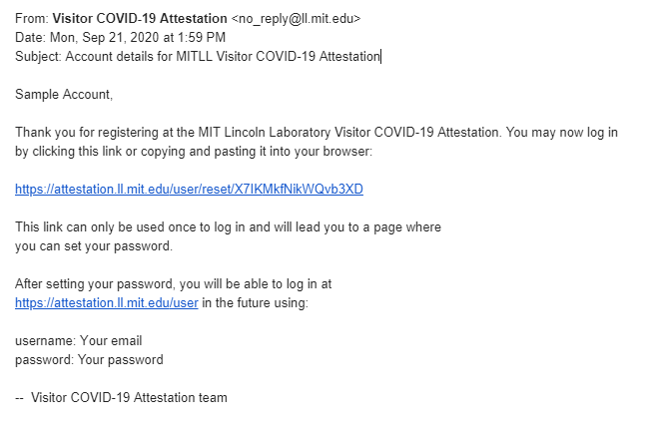
Attestation Form
Once logged in, you will complete the Attestation Form. All fields are required. Once all fields are completed, click the “Continue” button to move to the next screen.
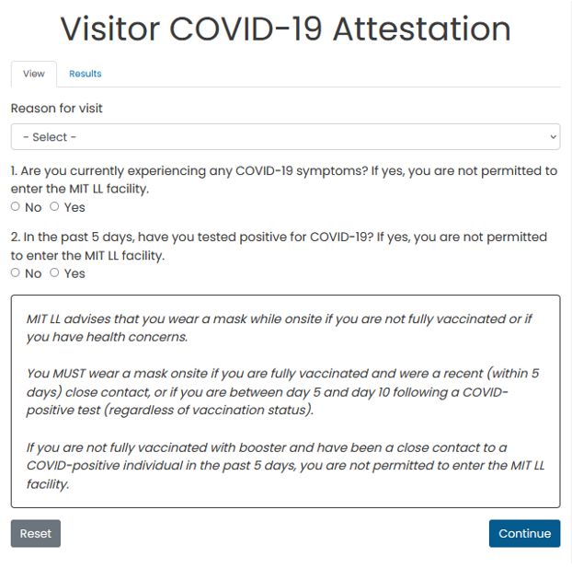

Note: The Attestation Form must to be completed daily.

If your responses indicate that you DO NOT have COVID Symptoms:
Click on one of the action buttons to continue.

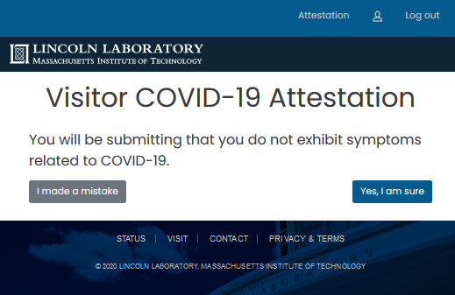
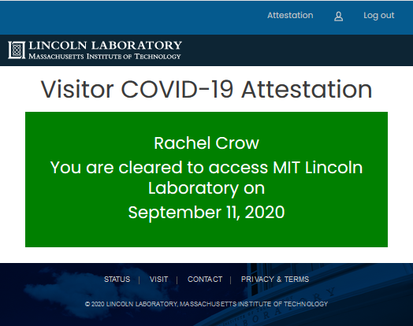

Email notification:
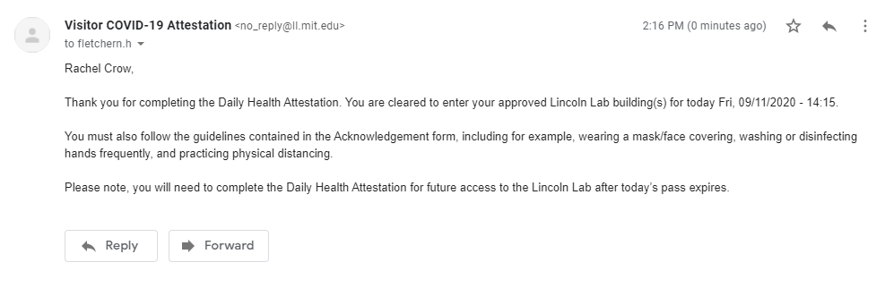
This approval is only good for the date listed.
If your responses indicate that you DO have COVID Symptoms:
Click on one of the action buttons to continue.
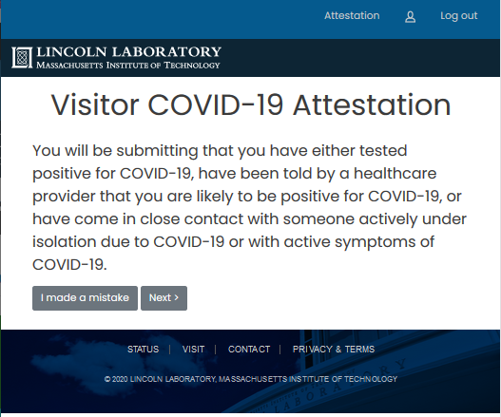
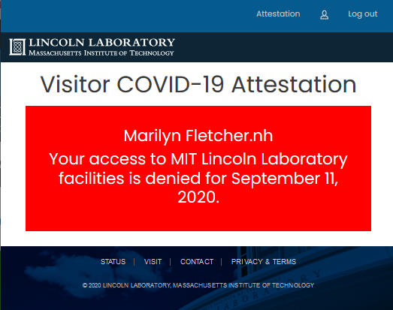
Email notification:
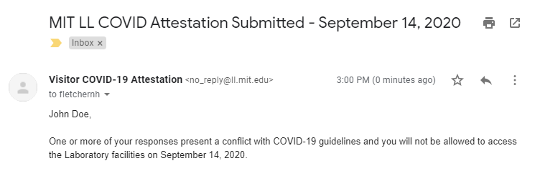
If any of your responses present a conflict with COVID-19 guidelines, you will not be allowed to access the Laboratory facilities. Security personnel will be will be notified of your status.

A paper process will be available for those who are not able/willing to download the application onto their electronic device, are not authorized to use the electronic system and as a back up to the electronic process. You can download the paper form - Visitor Screening Questionnaire.
The attestation form must be completed each day you visit the Laboratory and needs to be completed on the day of your visit.
The completed form will be presented to the Security Services Representative at sign-in (see below). If any of your responses present a conflict with the Laboratory’s current COVID-19 guidelines, you will be denied access to the Laboratory facilities/grounds.
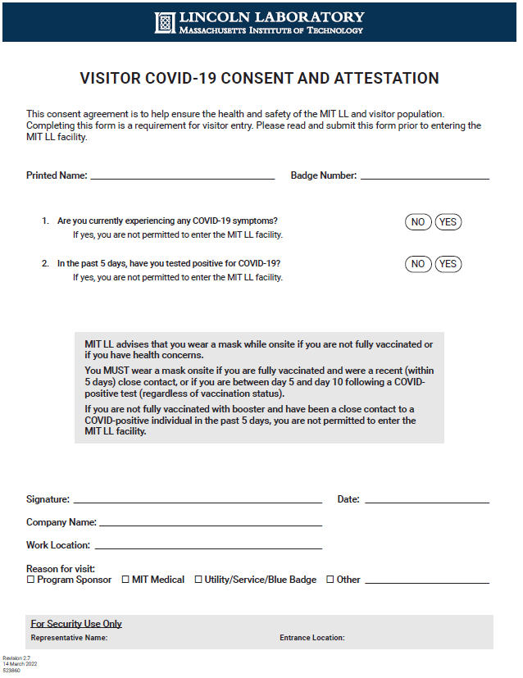

For additional Visitor information, please click on the following link: https://www.ll.mit.edu/contact-us/visitor-information.

